For this activity I wrote my code in the programming language **Java**. I also want to add, having been on the course I am more competent to also write and certainly read the programming language **C#**. I use the IDE (Integrated Development Environment) **Eclipse** to write and run my code for this activity. The IDE **Visual Studio Code** was also an option for me, having installed the required extensions.

Below are snippets of my **class digram**, the **key part of my code** and the **end result**.

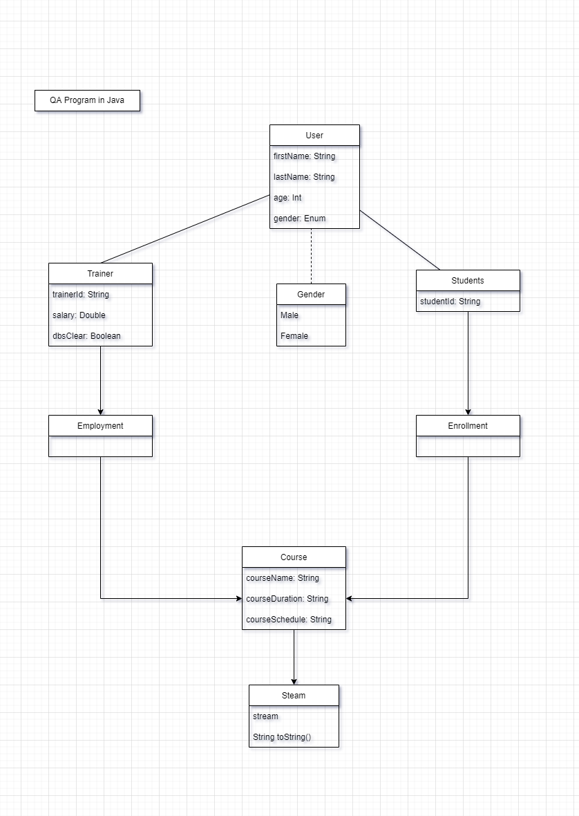

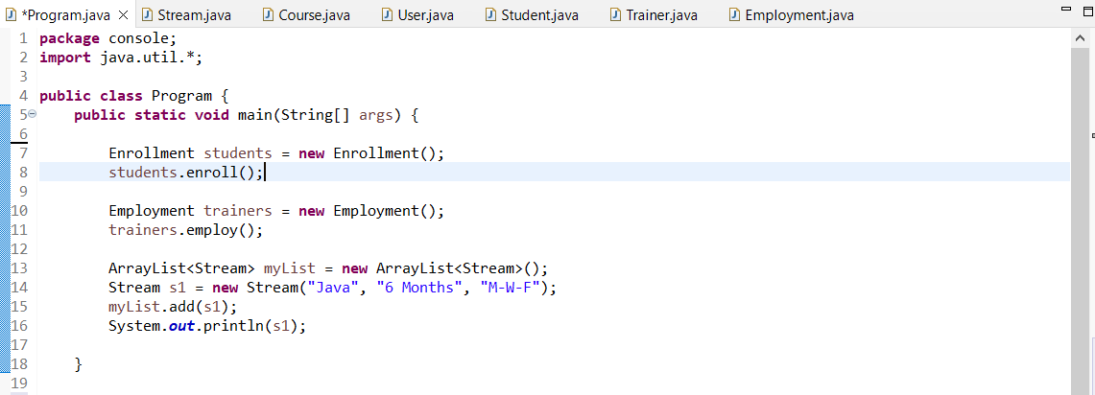

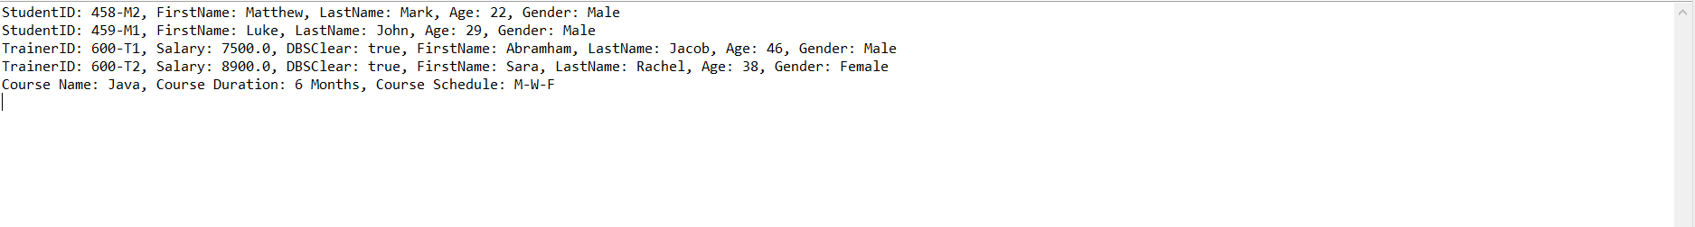

On this activity, the part I found easy was sectioning my code into smaller section, smaller object. Therefore, with ease I am able to code and align to the Java Object Oriented concept. So I identify the objects which are required for my program along with it’s variables, data types, methods and constructors. Using the **Eclipse** IDE to write my code, I was able to follow the Java naming convention with ease, as the **Eclipse** software will give me a warming should I depart from the Java naming convention.

The part I found **challenging** on this activity was fully understanding the whole concept of stream and I did my best to write my code base off that understanding. So I decided to use the Java collection **ArrayList** to help implement the stream concept.

Another aspect of this activity I found **challenging** was drawing my **UML diagram**, I wasn’t sure which tools/programs to use to draw my diagram. I did some research on the internet, there are some free resources available such as Lucidchart where registration is required. I ended using **app.diagram.net** as it was free and easy to use right a way.

Thank you for your time.